**What we will be doing in class today # ___**



Presentation*…of work completed.*



Group discussion*…about the topic.*



Writing*…taking down notes.*



Reading…*more information about the topic.*

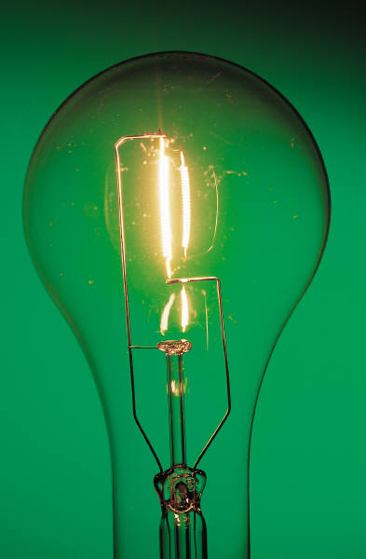

Thinking… *about what has been discussed.*