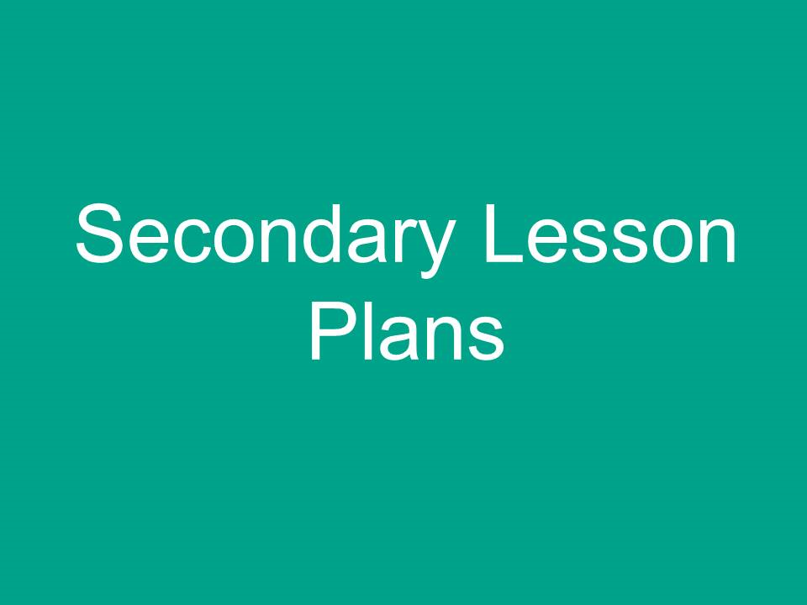
Introduction
No Pens Day Wednesday activity templates and lesson plans have been created by specialist teachers and speech and language therapists and quality assured by practising mainstream teachers.
Activity templates
We’ve provided activity templates, which are generic and can be adapted to any lesson (separate download on www.hello.org.uk/no-pens-day-wednesday). These give information about the activity and how it can be implemented as well as highlighting any resources / links that might be useful to support that activity. The activities can be used within any element of a lesson - as a starter activity, main activity, plenary or as methods of recording learning. See also separate guidance on ways of recording without using pens (available on www.hello.org.uk/no-pens-day-wednesday).
Lesson plans
These have been developed by taking example plans for September from one school’s planning as a starting point. As all schools will be covering different topics and have different ways of planning, the lesson plans provide an example for schools to adapt, though they can be used as they are if this fits in with your planning.
Lesson plans aim to follow good practice principles; e.g.
- They identify explicit learning objectives
- They support use of questioning, using Blooms taxonomy, to support learning
- They include plenary sessions that encourage pupils to reflect on their learning through assessment for learning strategies.
Some lessons include reflection on how the “no pens” theme of the day has affected learning. This could be a discussion you could have in any lesson in order to gather pupils’ views on how an emphasis on talk in the classroom has impacted on their learning and enjoyment of lessons.
Each lesson plan also has key vocabulary identified, signposting to the vocabulary section of the activity templates. Vocabulary is key to all learners, particularly those whose language is not at an age appropriate level and those learning English as an additional language. Teaching vocabulary explicitly as part of the lesson, using tried and tested strategies, can make a significant difference to these pupils in particular.
A speaking and listening objective has also been identified for each lesson. These have been taken from our Universally Speaking guides, which track language development throughout the secondary years.
Lesson plans are available for year 7 across all subject areas; this is not to limit your No Pens Day Wednesday to year 7 only, but to provide an example which you can use and adapt for different year groups.
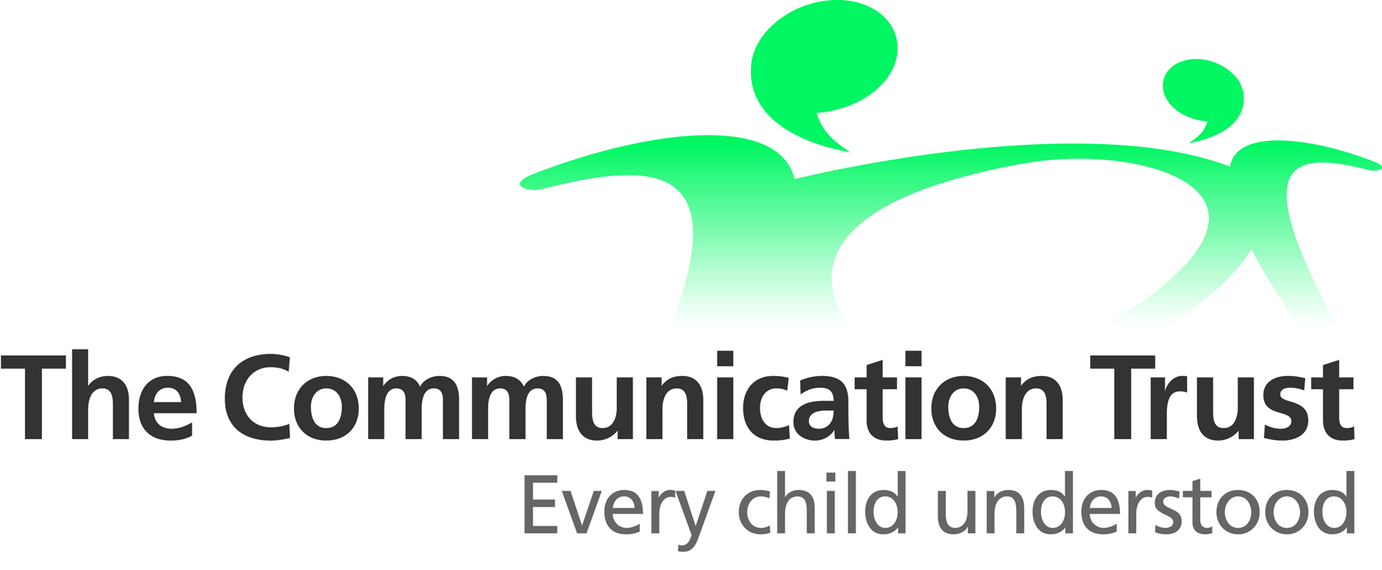
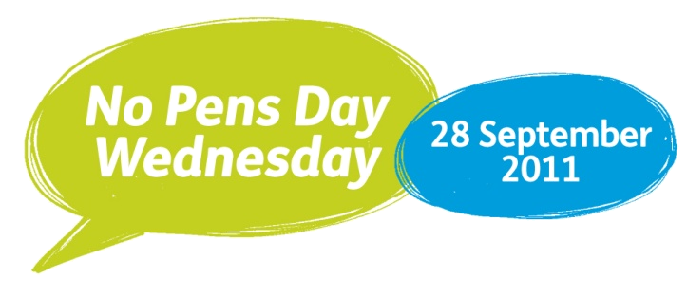
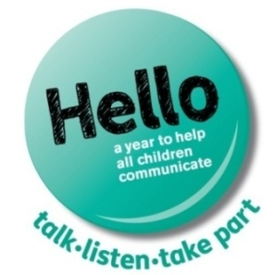
Science (Chemistry)
Year/Class: 7 | Teacher: | Date: |  | Scheme of Work: Chemical Reactions  Lesson Topic: What are chemical reactions?
Learning objectives:  - To recognise the differences between a chemical and physical change  - To identify the main features of a chemical reaction |  |  | Speaking and listening objective:  Explain the a sequence of events in a simple but accurate way, using appropriate terminology
Key Questions / Concepts:  - What is happening in the reaction?  - Can you change it back?  - What product is formed?  - Is it a chemical or physical change? How do you know? |  |  | Resources:  - PowerPoint on ‘Reversible and Irreversible Reactions, Physical and Chemical Changes’ by Cressida Bowden  http://www.tes.co.uk/teaching-resource/Reversible-and-amp-Irreversible-Physical-and-amp-Chemical-6081216/  See ‘Activity, Chemistry in Everyday Life’  - ‘King Kong’s Hand’ resources. See ‘Activity’ http://www.tes.co.uk/ResourceDetail.aspx?storyCode=6046213  - Resources for practical per ’Reversible and Irreversible Reactions, Physical and Chemical Changes’ by Cressida Bowden  http://www.tes.co.uk/teaching-resource/Reversible-and-amp-Irreversible-Physical-and-amp-Chemical-6081216/  See ‘Activity, Experiment Cards’  - Dice
Activities
Starter:
King Kong’s hand demonstration
- Students to describe what’s happening
- Teacher recap and reinforce features of chemical reactions observed

Chemical or physical changes?
- Pictures of everyday activities (per PowerPoint)
- Students to remain seated for physical changes, stand up to indicate chemical changes
- Teacher led discussion about features of chemical changes / reactions e.g. frying an egg, boiling water, fireworks, ice cream melting, barbecue, bonfire etc
- Reinforce that chemical reactions can be reversible or irreversible
Vocabulary: Changes, reaction / chemical reaction / physical reaction, reversible / irreversible, state / temperature, substances / reactants / products
Teach vocabulary using strategies and materials from the activity templates available to download at www.hello.org.uk/no-pens-day-wednesday
Main:
Practical (per Experiment Cards)
- Divide students into 6 mixed ability groups. Each group to carry out one of the experiments
- Students to decide amongst group members who will feedback to whole class group re. description of experiment, the group’s hypotheses, what changes took place, decision whether chemical or physical reaction took place / whether reversible or irreversible reaction and what evidence for these judgements
Feedback to whole class group re. practical
- Listeners to agree / disagree with group’s decisions / judgements and whole class discussion on how a chemical reaction can be reversed (or not)
Plenary/assessment for learning:
‘Round Robin’ with dice (whole class)
- Odd number – student describes one feature about chemical reaction or when this takes place
- Even number – student describes one feature about physical reaction or when this takes place
Ask students to talk to a partner and decide which of these they can now do, and what they need to learn next:
- Recognise the differences between a chemical and physical change
- Identify the main features of a chemical reaction
- Identify whether a chemical change is reversible and /or how it can be reversed

Differentiation / Strategies:
- ‘What’ concrete questions, give alternatives if needed
- Visual and simple definition of keywords
- Whole class ‘think time’ before answering question asked
- Adult facilitation to encourage all students in small group to take turns / participate
- Pair weak reader with better reader as ‘buddy’ when reading instructions for practical
- Assign roles and responsibilities to specific students in practical if needed
- Allow repetition of answers already given and / or give clues about an alternative answer

Art
Year/Class: 7 | Teacher: |  | Date: | Scheme of work: Drawing/ Painting Lesson Topic: Colourful Klee
Learning objectives:  - To define what are primary, secondary and tertiary colours  - To mix secondary colours  - To describe one piece of work by Paul Klee and to give own opinion about it |  |  |  |  | Speaking and listening objective:  To use objective and clear “dictionary type” definitions of the words primary, secondary and tertiary
Key Questions/ Concepts:  - What are the primary colours?  - What are the secondary colours? How are these made?  - What are the tertiary colours? How are these made?  - What do you think the painting is about?  - What mood or emotions come across? |  | Resources:  - ‘Playing card’ sized Paul Klee paintings  - Large colour wheel (for demonstration)  - Large colour wheel with names of colours clearly labelled  - PowerPoint slides re. Paul Klee paintings  - Visuals for ‘emotions’/ adjectives vocabulary:  http://www.lancsngfl.ac.uk/nationalstrategy/ks3/behaveattend/getfile.php?src=242/feelingscard.pdf  Icons/graphics for feelings words can be found  http://teachfind.com/national-strategies/seal-resource-sheet-words-core-feelings  This is the link for photo cards of emotions  http://teachfind.com/national-strategies/seal-curriculum-resource-photo-card-collection
Activities
Starter: Pairs Memory Game
Use a selection of Paul Klee pictures. Work in pairs. Lay all pictures face down, take turns to turn over and match the pictures – name a primary and secondary colour in the paintings in order to win the pair
Vocabulary: Primary / Secondary / Tertiary colours, spectrum, mixing, abstract, interpret, conveyed, mood / emotions, colour properties / association
Teach vocabulary using strategies and materials from the activity templates available to download at www.hello.org.uk/no-pens-day-wednesday
Main:
Demonstration re. secondary and tertiary colours
- Questions to re-cap on primary/ secondary/ tertiary colours
- In groups decide on a definition for each of the terms primary, secondary and tertiary; groups pair up and agree on a definition – all feedback and discuss
- Discussion re. colour properties/ associated emotions
Students to continue with own colour wheel (from previous lesson)
- Mix and colour in secondary colours on colour wheel
- For higher achieving students mix tertiary colours also
Paul Klee paintings discussion (whole class)
- Individuals’ interpretation of abstract paintings
- The use of colours to convey mood/ emotions
- Reinforce a range of adjectives to describe the work. Support with visuals for vocabulary
Paul Klee paintings discussion (in pairs)
  - Each student selects one work from paintings used in Pairs Memory Game.
  - Discuss: What do you think the painting is about? What mood or emotions comes across? How does Klee convey that mood?
Each student goes to find another student with the same picture – compare ideas and think of adjectives to describe the work
Each pair feeds back their findings to the class and compares pictures where similar adjectives have been used. What can you say about the similarities and differences in these pictures?
Plenary / Assessment for learning:
Play a memory game, asking pupils to name a colour and an adjective associated with it, the next student copies the first and adds their own – e.g. I fell into a Paul Klee painting and saw midnight blue....I fell into a Paul Klee painting and saw midnight blue and vibrant pink...I fell into a Paul Klee painting and saw midnight blue, vibrant pink and pale yellow ....etc. Differentiate by choosing lower achieving pupils first, higher achieving pupils last
Assessment for learning :
- How confident are you in naming the primary colours – use traffic lights to indicate
- The secondary colours
- In pairs, give a definition of primary, secondary and tertiary colours; peer assess for accuracy
Differentiation/ Strategies:
- Visuals, such as pictures and symbols to support simple definition of keywords – see suggestions in the “activity template” section for different ways to support learning of vocabulary
- Thinking time – tell student X you will ask him/her after you’ve asked student Y
- ‘Talk then paint’ – adult to check with student re. what colours to mix before painting on colour wheel
- Adult facilitation to encourage all students in small group to take turns/ participate
- Support ‘What mood or emotions comes across?’ with visuals for ‘emotions’/ adjectives vocabulary

Citizenship
Year/Class: 7 | Teacher: | Date: | Scheme of work: The Justice System Lesson Topic: Laws and Crimes
Learning objectives:  - To know what a law is  - To know how laws are made  - To consider why we have laws |  |  | Speaking and listening objective:  See someone else’s point of view when ‘arguing’, whilst being able to present clear argument from a different perspective
Key questions / concepts:  - What do we mean by rules and laws ?  - Consider why societies and communities all have laws and rules  - What would happen if we didn't have laws? |  |  | Resources:  - Whiteboard  - Law making sequence cards  - “Why do we have laws?” cards + page pre-loaded on whiteboard (supplied below)  - Blank ranking outline for whiteboard
Activities
Starter:
What do you know...?
- Divide into 6 groups – 2 groups discuss crime, 2 discuss punishment and 2 discuss people who work in the legal / justice system. Groups discussing the same thing join together and pool ideas
- Each bigger group feedback to the class. Teacher adds to spider grams on whiteboard on the 3 topics
Vocabulary: Legal, justice, parliament, punishment, enforce, Bill, MP, sentence
Teach these key words using activity templates for teaching vocabulary from the activity templates available to download at www.hello.org.uk/no-pens-day-wednesday. At intervals throughout the lesson , call out a definition and see if pupils can give you the right word. Have groups choose one of the words and ask another group for the definition. Highlight the difference between similar sounding words –e.g. parliament and punishment – with pictures of each.
Main:
Teach the sequence of law making
- Identify pairs of students to represent the different sequences of law making. Once they have been identified, have them place themselves in the correct order at the front of the class. Once agreed, other pupils should decide whether they order is correct and if not, make suggestions.
- Whole class should feedback; select pupils to retell the sequence in order – first while looking at the other pupils, then without looking (receiving help from others if needed).
- Brief brainstorm - Why do we have laws? Go through “Why do we have laws?” Reasons on cards
- Individual thinking time then group work. Ranking exercise “Why do we have laws?” Ranking doesn't have to be vertical – can have reasons of equal value. Ideally it will end up as a diamond shape.
- Whole class feedback for consensus.
- Teacher records rank on to pre-loaded diagram on whiteboard.
- Group/pair discussion work - “What do you think is the worst crime and why?” “What would be a suitable punishment and why?” Emphasise it's OK to disagree as long as you have reasons.
Plenary / Assessment for learning
Whole class to feedback, identifying what they think is the worst crime and giving strong and convincing arguments. The class should then vote on worst crimes and suitable punishments. Teacher to model giving a clear and strong argument for what is the worst crime (choose something minor – e.g. spitting, with a harsh punishment e.g. prison, to demonstrate how to argue your case).

Assessment for learning: How confident are you in remembering the sequence of law making – talk with your partner about what would help you remember
How strong was your argument for the worst crime? What could you do to improve your argument?
Differentiation/ Strategies:
- Teaching and display of key vocabulary; make links between new vocabulary and current knowledge/ experience.
- Visual and kinaesthetic activities -sequencing and ranking.
- Peer support through mixed ability / group work.
- Thinking time.
- Make an audio recording of the text of Law making sequencing cards and Why do we have laws card, using single message ICT devices such as Talking Tins, Talking buttons, talking postcards or tell-a-story cards (www.speechbubble.org.uk)

Resource: Why do we have laws?
Diamond ranking

To suppress the people so the government can have control.
To protect innocent people and keep them safe.
To prevent anarchy.
To tell people how to behave.
To protect our human rights.
So people can keep what belongs to them.
To keep people safe.
To give justice to the people.
So people don't live in fear.
So rules can be broken.

Resource: Sequencing of law making

A bill is introduced into the House of Commons – they have the 1st reading.
MPs debate the bill during the 2nd reading.
A committee of MPs analyse the bill and send it back to the House of Commons.
The MPs in the House of Commons have a 3rd reading and vote on the proposed law.
If the MPs vote for the law it goes to the House of Lords.
The Lords debate the bill – they usually accept it. They can only reject it 3 times.
The bill goes to the Queen and she signs it. This is called the Royal Assent. The bill becomes a law.
Drama
Year/Class: 7 | Teacher: | Date: | Scheme of work: Drama Techniques Lesson Topic: Mime and Characterisation
Learning objectives:  - To identify how body, gesture and facial expressions are used to convey the intended messages in mime  - To identify and show a range of contrasting facial expressions  - To create a mimed scene |  |  | Speaking and listening objective:  Follow spoken directions which are quite complex – so a possible combination of longer sentences with more information, maybe new vocabulary and more complex grammar.
Key questions / concepts:  - What is tableau?  - How is tableau different to mime?  - What do facial expressions show?  - What else shows you how the person is feeling?  - Why is body language important?  - Explain how body language and facial expression can be interpreted in different ways by different people |  |  | Resources:  - Clapper board  - Pictures/ PowerPoint slides of items that elicit different reactions  - Postcards for Pair It Up miming game  - Visuals for ‘emotions’ vocabulary  Icons/graphics for feelings words can be found here:  http://teachfind.com/national-strategies/seal-resource-sheet-words-core-feelings  Photo cards of emotions can be found here:  http://teachfind.com/national-strategies/seal-curriculum-resource-photo-card-collection
Activities
Starter: Clapper board Tableau
  - Introduce the idea of a ‘Tableau’. Have a mime area of class and tableau area – give different descriptions and have students run to the area they think represents either mime or tableau. Ask students to summarise the difference between a tableau and a mime.
  - Teacher shows pictures/ PowerPoint slides of different items that elicit different reactions, e.g. a winning lottery ticket, a snake, a bomb, Justin Bieber, a kitten, a rollercoaster etc.
  - On the count of 3-2-1 + clapper board, students mime and hold their reactions.
  - Teacher identifies 1st good example, who then identifies another good example etc.
  - Highlight the use of body language as well as facial expressions.
Vocabulary: Mime, facial expressions, emotions, gesture, body language, exaggeration/ dramatic
Teach vocabulary using strategies and materials in the activity templates available to download at www.hello.org.uk/no-pens-day-wednesday
Main:
Mime demonstration
- Volunteers to improvise and mime:
- ‘It’s George’s birthday. Grandma and Grandpa arrive with a present. George unwraps the presents. It’s the latest WII Sport game that he wanted’.
- Repeat the script but the present is a pair of Justin Bieber slippers.
- Can you compare the first and second scenes; Discussion re: similarities and differences between the two scenes.
- How do you know how he/she feels? Highlight the contrasting body language, gestures and facial expressions.
Students’ mime (groups of 4)
- In groups of 4, students to create a mime lasting 1-2 minutes that includes contrasting emotions.
- Encourage students to think carefully about a character and how they would respond to different situations
Show mime to class
- Audience (students) to identify effective use of body language/ gesture/ facial expressions.
- Audience (students) to identify what to change/ work on.
Plenary / Assessment for learning:
Pair it Up mime
- Students are given either a ‘mime + emotion word’ (e.g. mime bored) card or ‘emotion word card’ (e.g. bored).
- Students with ‘mime+ emotion word’ card take it in turns to mime emotion to whole class.
- Student with the matched ‘emotion word’ card identifies what the emotion is.
- AfL – in groups; in what way did people manage to stay in character during mimes; what would help to do that more effectively.
- How well did you follow directions at the beginning of the lesson; consider what you could do to help you listen and understand spoken directions.
Differentiation/ Strategies:
- For lower achieving students, give two / three pictures to demonstrate emotions to support the mime, suggest emotions that are easier, e.g. happy, excited etc. For higher achieving students, they should be given a range of more emotions to demonstrate, including those that are more complex or subtle, e.g. bored, frustrated, indifferent, elated
- Thinking time – tell students you will ask them after you’ve asked student x
- Adult facilitation to encourage all students in small groups to contribute and to participate
- Adult to support use of simple ‘wh’ (who/what/where/why) questions to guide planning for group mime
- Make available visuals for ‘emotions’ vocabulary

Design and Technology (Textiles)
Year/Class: 7 | Teacher: | Date: |  | Scheme of work: Fibres and Fabrics Lesson Topic: Fibres and Fabric Constructions
Learning objectives:  - To give examples of natural and manmade fibres and to identify where they come from  - To identify the main characteristics of some of the fibres  - To identify 2 different constructions of fabric |  |  |  |  | Speaking and listening objective:  Talk using sentences of around 7-11 words
Key questions / concepts:  - What do we mean by textiles?  - Why are textiles important to society?  - What do we mean by natural fibres  - What do we mean by man-made fibres?  - What are the characteristics of this fibre?  - Where do natural/ manmade fibres come from?  - How are fibres made into fabrics? |  |  | Resources:  - Photos of a range of familiar textiles made from a variety of fibres (complete/ partial images)  - The Fabric of Society by Mrs Zubairy, Edenham High www.youtube.com/watch?v=eCqsEaYv70s  - Range of fabric samples made from a variety of fibres  - Optionally – a favourite item of clothing each student has been asked to bring from home  - Flashcard sized cards; name of fibre, description of where it comes from and/or main characteristics  - A/B/C/D cards for multiple choices  - Keywords display
Activities
Starter: Guess What? Work in pairs
- Identify what the item is from a photo that shows only a part of it e.g. towel, leotard, swimming shorts, sports fleece, sock, gloves, rucksack, jumper, scarf, cap, curtains, table cloth, pillow, flag, teddy bear etc. Sort into three piles whether the item is made from ‘man-made fibres’, ‘natural fibres’ or ‘either’
- Show complete photo of items (on slides). Discuss which category each belongs to.
Vocabulary: Textiles, natural, man-made / synthetic, chemicals, fibres / yarn, fabric / fabric construction, woven / knitted, characteristics/ properties
Teach vocabulary using strategies and materials in the activity templates available to download at www.hello.org.uk/no-pens-day-wednesday
Main:
Introduce ‘textiles’
Find a common link between all the photos shown – the word ‘textiles’ refers to any item made out of fabric. Highlight and refer to keywords display.

YouTube presentation: The Fabric of Society
Reinforce information using ‘Who Wants To Be A Millionaire’ format quiz.
Questions to highlight information relating to:
- Why are textiles important to society?
- What are natural fibres/ man-made fibres?
- What are the characteristics of this fibre?
- Where do natural/ manmade fibres come from?
- How are fibres made into fabrics?
Students work in groups of 5’s. Each question to be answered by a different student – hold up either A/B/C/D card. If unsure, can ask team members; ‘phone a friend’ or ‘ask the audience’ or to request answers card for 50:50. Students hold up answer card when asked ‘What’s your final answer?’

What is it made out of?
Work in pairs to decide what fabrics/fibres the favourite items of clothing brought from home are made of , and the features of the fabric e.g. This is made of natural fibres so it doesn’t make me feel hot when I’m dancing, or match name of fibre to description of where it comes from / characteristics and to each fabric sample supplied by teacher (linen, cotton, nylon, wool, silk, viscose, Lycra, acrylic, polyester)

Whole class feedback to include whether the fabric is knitted or woven

Going shopping! In pairs
You are planning to buy a new item of clothing – jumper/coat/trousers etc. Explain to your partner what fabric would you want it made of and why – justify why you want that fabric
Plenary / Assessment for learning:
Guess Which One? (whole class)
  - Teacher describes a specific fibre, students to identify what the fabric sample is e.g. “This is manmade. It’s very strong and light weight. Kites and tents are made out of this” (nylon)
  - Each pair gives a description of a fabric for others to guess
  - Peer assessment on the speaking and listening objective – how well did people do in using longer sentences for their descriptions of fabrics
  - Say which activity in the lesson you found most useful and why
Differentiation/ Strategies:
- Demonstrate and model examples
- Visual + simple definition of keywords. Display, explain and refer to these
- Whole class ‘think time’ before answering the questions asked
- Differentiated questions in quiz, e.g. using Bloom’s taxonomy for questions:
Can you name the . . .? Can you tell why . . .? Find the meaning of . . .? What is . . .? Which is true or false . . .?
Can you explain in your own words . . .? Can you distinguish between . . .? What differences exist between . . .? Can you provide a definition for . . .?
- Select from a choice of 3 fabrics (re. Plenary activity)

English
Year/Class: 7 | Teacher: | Date: |  | Scheme of work: Reading and writing folk tales and fairy tales  Lesson Topic: Folk Tales and Fairy Stories
Learning objectives:  - To recognise shared features  - To recognise conventions of traditional stories |  |  | Speaking and listening objectives:  Follow spoken directions which are quite complex – so a possible combination of longer sentences with more information, maybe new vocabulary and more complex grammar
Key questions / concepts:  - Fairy tales and folk tales are a genre  - Comparisons and parallels  - What are the common themes?  - Stereotypes |  |  | Resources:  - Whiteboard  - Short version of any well known fairy tale  - Question sheet “Folk Tales and Fairy Stories” (supplied below)  - Dictionaries
Activities
Starter: “One thing I know about...”
- Students to think of a fairy story and say one thing about it – character, place, key object, event, e.g. Cinderella and a glass slipper; Red Riding Hood and the forest
- Teacher to list the stories on the whiteboard
Vocabulary: Similarities, convention, genre, representative, characteristic, stereotypical, features
Teach vocabulary using strategies and materials in the activity templates available to download at www.hello.org.uk/no-pens-day-wednesday
Main:
- Teacher reads a traditional story and discusses familiar features
- Main activity: jigsaw
- Split the pupils into 6 differentiated groups. Tell pupils that each group is going to become experts on one aspect of folk tales and fairy stories. The six aspects are:
- Heroes and villains
- Memorable phrases, chants or rhymes
- Quests/tasks/puzzles
- Special numbers
- Characters/stereotypes
- Settings
- Teacher explains notion of literary conventions and refers to key words
- Provide each group with their discussion questions. Tell them they need to remember the key points from the discussion, so that they share their expert knowledge with a mixed group, made up of experts on each of the six aspects, at the end
- In groups students discuss selected questions on the sheet
- Re-allocate students into mixed groups made up of one person from each of the expert groups
- Have them share their information
- Feedback to the whole class to share key features of traditional stories
Plenary / Assessment for learning:
- Round Robin – revisit “One thing I know about” starter activity. Go round the class with pupils choosing a story and describing one thing they know about it. Encourage them to think of as many different stories and key information as possible , e.g. The glass slipper was an important object in Cinderella, the apple was an important object in Snow White, the beans were important in Jack and the Beanstalk etc.
- How well do you know the features and conventions of traditional tales? Which activity has helped you learn about traditional tales? Talk with your partner about how you will remember what you have learned today. Where would being able to write things down help further?
- Think of how well you followed instructions of what to do – anything you could do to improve how you listened and understood instructions?
Differentiation/ Strategies:
- Differentiated groups for jigsaw activity
- Record jigsaw activity discussion questions , or pair weaker with better readers
- Lower achieving groups given jigsaw activity discussion areas that are more concrete and well known, e.g. heroes and villains
- Check understanding of questions
- Chunk information, giving information step by step for lower achieving pupils
- Adult to work with lower achieving group to model and rehearse a format for them to take back their information to the mixed group
Resource: Folk Tales and Fairy Stories
Many traditional stories share the same features. Start by naming the fairy stories and folk tales you know in your group.
Heroes and villains discussion questions: Many stories include a bad person or creature who threatens the hero or heroine of the story. Who are they?
What do they look like? Is there anything similar about the bad people in different stories?
The main character, hero or heroine often appears innocent or vulnerable. How is this impression created by the story?

Memorable phrases, chants or rhymes discussion questions: Many of these stories were passed on orally (they weren’t written down), so they often contain memorable phrases, chants or rhymes. Can you think of any rhymes or phrases in any of the stories? (Clue: Mirror, mirror.....) Count up how many your group can think of and try to remember in order to feedback.

Quests/tasks/puzzles discussion questions: Which stories can you think of in which the hero or heroine has to complete a task, go on a quest or solve a puzzle?

Special numbers discussion questions: Think of as many examples as you can in the story with being in groups of three the significant part of the story, e.g. sets of three people, three wishes, three tasks, three words. Are there any other numbers that are often used (e.g. seven)?

Characters/stereotypes discussion questions: The characters are usually simple, representative and stereotypical. Use a dictionary to find out what these words mean and then say whether you agree or not. Can you think of some examples (clue: look at the way men and women are represented in these stories). Think about the men in the stories. What are they like? What do they do? Then think about the women. What are they like? What do they do?
How are the men and women different?
Settings discussion questions: Many of the stories are set in the past, or in settings which are very different from our own world. Think of examples of jobs done by people in these stories. What sort of homes do the people have?

Geography
Year/Class: 7 | Teacher: | Date: |  | Scheme of work: Maps and locations Lesson Topic: GPS
Learning objectives:  - To know what a GPS is  - To understand how a GPS works  - To know the uses of a GPS |  |  | Speaking and listening objectives:  Explain a sequence of events in a simple but accurate way
Key questions / concepts:  - How GPS works  - How GPS is used |  |  | Resources:  - Whiteboard  - Film and quiz from http://www.tes.co.uk/ResourceDetail.aspx?storyCode=6077230  - Question cards (supplied below)  - Number cards 1-4 for interactive quiz
Activities:
Starter: “Where am I?”
- Teacher to model a couple of examples
- Students must give 3 clues so the students can guess the familiar local location e.g. I can see, I can hear, people are
Vocabulary: Satellite, precise, global, location, vague, position, intersect, orbit, horizon
Teach vocabulary using strategies and materials in the activity templates available to download at www.hello.org.uk/no-pens-day-wednesday
Main:
- Brainstorm how else we can find out where we are and how to get somewhere. Prompt for GPS
- Introduce short film on a GPS system
- Explain there will be questions after the short film, so they should listen out for the answers
- Hand out question cards to pairs/groups
- Play film
- Pairs/groups discuss questions and feedback to class
- Teacher puts up interactive quiz (use “review quiz” option) on whiteboard
- Pairs/groups to discuss and agree answers to interactive quiz on white board. One member of group to hold up the card for the number they have chosen, choose pupils to tally, teacher enters majority choice on interactive quiz
- In groups think about how you would get from where you are now to another part of the school. Each person in the group takes a role; four are satellites sending messages, one the receiver and one the person moving. Consider how you are going to make your human GPS system work. What will you need to consider? What might be the difficulties? Plan out your route, then work out how the satellites will pass messages to the receiver and the receiver to the person moving. How successful was your plan? How well did communication work between you? What could you do to improve it? Summarise your evaluation of the task to feedback to class in a concise way.
Plenary / Assessment for learning:
Play: Here is the answer, what is the question?
- Teacher compiles list of topic related ‘answers’
- Differentiate for lower achieving pupils
- Pupils talk to a partner and then take turns to provide questions to go with the answers in the style of the game ‘Jeopardy’
Reflect on what you know about the GPS system. With a partner consider what are the key features of the GPS system? How successful were you at feeding back your findings of the group task to the class? How clear, well organised and accurate was it? What about your use of technical words to describe things? What could you do to make it better?
Differentiation/ Strategies:
- Teaching and display of key vocabulary, using templates provided in the activity template pack and use fewer examples of technical vocabulary for lower achieving pupils
- Peer support through pair/group work, using mixed ability groups and giving lower achieving students specific roles, for example one of the satellites
- Giving additional thinking time during quiz for lower achieving pupils
- Information presented visually
- Differentiated questioning, choosing more concrete questions in the plenary session and a specific number of points in reflection task

Resource: Question Cards

What does GPS stand for?

How many satellites orbit the earth?

What does ‘altitude’ mean?

How many satellites are above the horizon at any one time?

What does the 4th satellite do?

What do many receivers have built in?

Voting cards
A | B
C | D

Questions
- What does GPS stand for?
- How many satellites are there?
- Where do satellites orbit?
- How many satellites doe the GPS receiver receives information from?
- What 3 things do the satellites provide information about?
- How do they transmit the information?
- What is special about the information that is transmitted? The information is transmitted in special ______ which the receiver understands.
- What are built into many receivers?
- What word would we use to describe the exact place we are in?

Answers to the questions

space
30
codes
location
Global Positioning System
latitude longitude altitude
4
maps
radio waves

History
Year/Class: 7 | Teacher: | Date: |  | SOW: Medieval Britain Lesson Topic: How did William of Normandy grasp control of England?
Learning objectives:  - To learn about William the Conqueror's victory at the Battle of Hastings  - To learn about some of the characteristics of successful medieval rulers  - To select evidence from the Bayeux Tapestry to support an argument |  |  | Speaking and listening objective:  Explain a sequence of events in a simple but accurate way
Key questions / concepts:  - Where is Normandy?  - Who was William?  - 1066 on timeline  - Sequence of main events  - Bayeux tapestry as source of information  - Bayeux tapestry illustrates several aspects of William's personality  - Forward planning  - Strategy |  |  | Resources:  - Whiteboard  - Images of Bayeux tapestry http://www.bayeuxtapestry.org.uk/Index.htm (explanation, scenes and descriptions)  - Images on cards to sequence - website provides printable resource  - Caption cards to match to pictures - website provides printable resource
Activities
Starter: Word Wall
- Ask students to contribute words connected with William the Conqueror
- Teacher types onto word wall on whiteboard and saves. See example below
Vocabulary: Tapestry, medieval, monarchy, source, nobility, strategy, feudal, conquest
Teach vocabulary using strategies and materials in the activity templates available to download at www.hello.org.uk/no-pens-day-wednesday
Main:
- Introduce the Bayeux Tapestry as a source of information about the events surrounding the Battle of Hastings. Show and explain the scenes on the tapestry.
- Ask the whole group to identify key points in the sequence of events. Choose a pupil to represent each key point and stand in a line representing the sequence. When the sequence (and pupils) is in place, retell the narrative of the sequence of events
Consider William the Conqueror as an example of a 'successful' monarch
- Reporter’s activity - What makes a successful king?
- Students work in pairs as interviewer and interviewee and then swap roles. They need to find out what is needed to be a successful king? Feedback to the class should be in the form of a news bulletin
- ‘This morning I spoke to William the Conqueror about what makes a successful king and this is what he told me...’
- Class feedback to establish a working list, e.g. intelligence, bravery, military skill, support from others, forward planning and put on whiteboard
- Return to the Bayeux Tapestry account of the Norman Conquest
- Distribute pictures and ask students to work in groups, to identify aspects of the tapestry that show the qualities needed by a successful king
- Ask pupils to think of any qualities that the Bayeux Tapestry does not identify and to speculate what kind of sources might contain such information
- Discuss the findings and produce a class list of qualities
- Locate William the Conqueror on the class timeline and family tree
Plenary / Assessment for learning: Back to the wall
In pairs – each pair adds one word to the wall and makes a statement using that word or another from the wall
Revisit the sequence by bringing the pupils who were involved in the sequencing activity back to the front of the class – whole class to help them get into the right order and retell the sequence of events
Reflect on how able you would feel to recount the sequence of events in a simple but accurate way – use traffic lights to indicate
What conclusions can you draw about what makes a good king? How will you remember this in relation to William?
Differentiation/ Strategies:
- Display, explain and refer to key words, identify fewer key words for lower achieving pupils
- Differentiated interview activities; lower achieving pupils given specific information to find out through differentiated questioning. More able pupils to provide a deeper analysis
- Pair work for peer supported learning
- Visual support or sound caption cards using single message recording devices given with pictures to support analysis of the tapestry

Medieval Word Wall
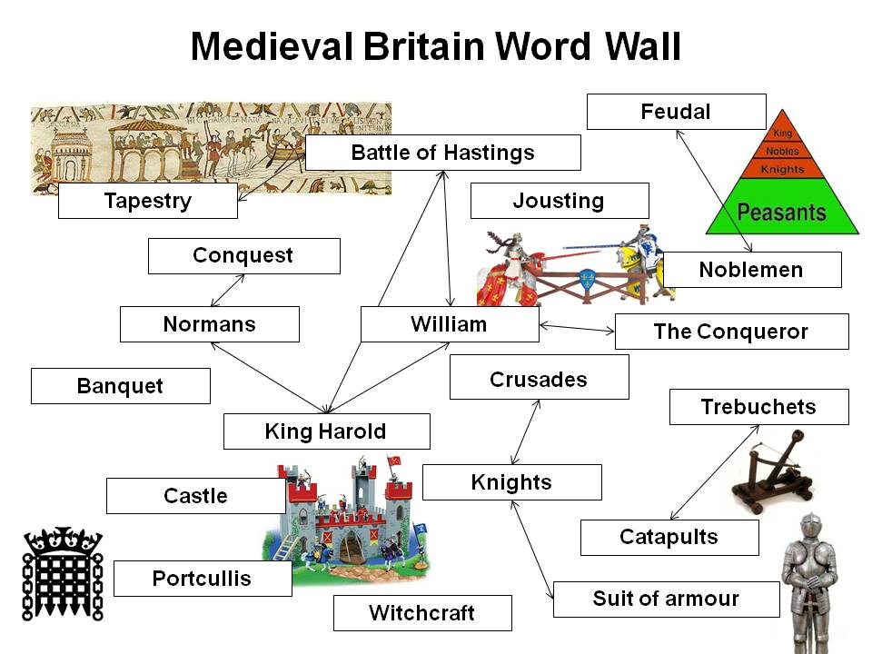
ICT
Year/Class: 7 | Teacher: | Date: | Scheme of work: E-safety Lesson Topic: E-safety assembly
Learning objectives:  - To understand what E-safety means  - To understand how to stay safe  - To create a demonstration of dangers and how to stay safe |  |  | Speaking and listening objectives:  - Change the style of their language to suit the situation and the listener  - Be aware when someone doesn’t understand, and try another way to get information across
Key questions / concepts:  - What does E-safety mean?  - What dangers are there?  - What can you do to stay safe?  - Who is the poster aimed at?  - What message or information are you trying to get across?  - How are you going to get the message across? |  |  | Resources:  - PowerPoint on E-Safety (with visuals to support keywords)  http://www.tes.co.uk/teaching-resource/E-safety-Outstanding-Lesson-6047127/ see ‘Game, Puzzle, Quiz’
Activity
Starter: Call My Bluff
- Work in groups of 4s
- One person says something about him/herself (e.g. “We’ve got 3 dogs and a cat”). Others have to decide if it’s true or not. One point for each correct answer
- Go round the group a few times
Vocabulary: Internet, chat rooms, cyber bullying, audience, caption, message, presentation
Teach vocabulary using strategies and materials in the activity templates available to download at www.hello.org.uk/no-pens-day-wednesday
Main:
Discussion to introduce E-Safety: Who are you talking to on the Internet? How do you know what the person saying is true? Relate back to Call My Bluff game.
- PowerPoint and discussion on E-safety: what dangers and how to stay safe re. internet, chat rooms, cyber bullying
Plan, do, review – group work:
- Set a task for pupils to plan part of an assembly for the rest of their year group on understanding what e safety means. Each group focuses on a different area of e safety as directed by the teacher, e.g. some of the dangers of the internet; chat rooms, cyber bullying, sharing information and how to stay safe
- Pupils to consider how they will make information interesting, engaging and understandable to the audience
- Pupils must agree a plan of what the assembly will cover and who will do which elements. They should be encouraged to include a short scene showing the dangers of the internet / how to stay safe
- Demonstrate their assembly section to other pupils; the rest of the class watch and suggest ways dangers can be avoided and other ways to stay safe
Plenary / Assessment for learning:
- Round Robin – one thing I know about the dangers of the internet and how to stay safe – go round the class with each person giving one example, choose lower achieving students first, higher achieving last
- Reflect on how well you did in making the assembly good for your audience; peer assessment – what did each group do well in their assembly and what could be improved. Focus on content and presentation; tone of voice, use of words, use of scenes, organisation, ensuring the audience could understand
Differentiation/ Strategies:
- Demonstrate examples using students
- Ensure understanding of true and false for starter activity – pre teach this vocabulary if needed
- Visual + simple definition of keywords. Display, explain and refer to these, using activity pack
- Whole class ‘think time’ before answering question asked and specific narrower questions for lower achieving pupils
- Visual support (PowerPoint)
- Differentiated task sheet with increased ‘step-by-step’ instructions/ what to consider
- Adult support and model good and poor examples of collaborative talk and presentation skills to support pupils understanding and skills

Maths
Year/Class: 7 | Teacher: | Date: |  | Scheme of work: Numbers Lesson Topic: Ordering
Learning objectives:  - To understand the relevance of ordering to everyday life  - To describe relative positioning within an order |  |  | Speaking and listening objective:  - Pick up new vocabulary and use in context within the lesson
Key questions / concepts:  - What is an order?  - How is it ordered?  - Why is the order useful?  - How can you describe the order?  - How else can you describe the order?  - Can you suggest some good words for describing order? |  |  | Resources:  - Whiteboard  - Colour paper (6 different colours)  - Grand Prix running commentary (YouTube)  - Visuals to support examples of everyday life occurrences where order is important/useful
Activity
Starter: Use it Once (whole class)
- Tell students you will be creating a number line using all the students in the class – the number line will be 1-26 (number of students in class)
- One student rolls the dice; even number = add, odd number = subtract
- Make up a sum involving the operation as indicated by dice. The answer has to be one of the numbers on the number line – this is their number and they must stand up and place themselves in the number line
- Another student has a turn and must place themselves in a position relative to the first on the number line
- Go round the whole class until all numbers on number line have been taken
- Allow lower achieving pupils to have a turn towards the beginning of the activity
Vocabulary: Order / sequence, 1st / nth / last, before / in front / ahead, after / behind / followed by, between / middle of
Teach vocabulary using strategies and materials in the activity templates available to download at www.hello.org.uk/no-pens-day-wednesday
Main: Visuals + discussion re. ordering in everyday life (sizes, house/ building numbers, dictionary, library, calendar races etc)
Grand Prix (work in groups of 6)
- Each student is the driver of a Grand Prix racing car, each with a different colour paper bib indicating the colour of car.
- As each ‘running commentary statement’ is called out (by the teacher), students to order themselves in the correct position e.g. “And they’re off. Red is overtaking Green and Yellow. Now Green is in the lead. Blue is stuck between Yellow and Orange ----------------“
Grand Prix continuation
- In small group (of 6), 1 person is the race commentator. Others are different colour racing cars. Task as above but students make up their own running commentary statements.
- Each group to present and act out this to the whole class.
- Freeze frame – at different points in the grand prix, the teacher will shout out “freeze frame” and pupils should stop. Select one or two pupils from each group to describe where they are in relation to other pupils e.g. I am 4th in the race, in front of Jack but behind Zoe and in between Kyran and Imran. Set a challenge for pupils to use as many of the key words in the freeze frame as possible – which group are the winners?
Plenary / Assessment for learning: Order, Order
- Each student to give a statement about self that involves an order word e.g. “I’m before Jai on the register”, “I came first in high jump in Sports Day last year”
- How confident are you in using key words – thumbs to show
- In groups - What activity best helped you understand the importance of ordering; summarise the elements you are most confident with and identify one aspect you are less sure about. How does your knowledge of ordering apply to your everyday life. Gather examples from groups.
Differentiation/ Strategies:
- More able students to generate sums towards end of task when less numbers are available on number line, lower achieving students to have a turn towards the beginning
- Mixed ability groups, with higher achieving pupils supporting lower achieving
- Chunk information or give limited instructions during the grand prix activity, before instructions are given, say the name of lower achieving pupils
- Visual support, such as a coloured card to represent the car in the grand prix, symbols to represent positional words
- Whole class ‘think time’ before answering question asked
- Sentence starters and/or selection of ‘order’ words to be used (for students’ running commentary)
- Identify specific words to be used in the freeze frame activity

Music
Year/Class: 7 | Teacher: | Date: |  | Scheme of work: The Instruments of the Orchestra  Lesson Topic: Identifying instruments
Learning objectives:  - To identify the four sections of the orchestra  - To know the positions of the instruments in the symphony orchestra  - To name instruments  - To identify some instruments by sound |  |  | Speaking and listening objective:  - Pick up new vocabulary and use in context within the lesson
Key questions / concepts:  - Families of instruments  - Instruments produce sound in different ways  - Roles of different instruments |  |  | Resources:  - Whiteboard  - Blank orchestra layout diagram http://www.musicatschool.co.uk/year_7/instruments.htm  - Completed orchestra layout diagram  - Musical excerpts of different instruments http://www.musicatschool.co.uk/year_7/instruments.htm  - http://www.musicatschool.co.uk/year_7/instruments.htm  - Pictures of instruments  - Section labels (supplied below)
Activities
Starter:
- Brainstorm musical instruments – put on whiteboard
- Play “I went to a concert and I heard a.......” each pupil repeats previous and adds an instrument to the list (start again when the list gets too long to remember)
Vocabulary: Orchestra, percussion, woodwind, symphony, brass strings, conductor, baton
Teach vocabulary using strategies and materials in the activity templates available to download at www.hello.org.uk/no-pens-day-wednesday
Main:
Learning the instrument families and positions
- Teach families of instruments
- Working in pairs/groups students sort cards into families
- Teach positions – give pupils an instrument each – they must organise themselves into the correct positions – peer assessment – did they get it right?
Barrier game
- Students should sit back to back or put up a physical barrier between them, such as standing up a large book or folder. Working in pairs, student A has a completed orchestra layout diagram and student B has a blank.
- Student A has to give verbal instructions to student B to put correct labels on the diagram (on the left, next to, behind, etc. – no pointing or peeping allowed!)
Name the Instrument / family
- Play examples of instruments and identify by name
- Ask students to name family
- Here’s the answer, what’s the question
- Play in groups
- The teacher gives an answer for each group – e.g. flute, cello, guitar, triangle, trumpet etc. Pupils must make up a question in groups – class to work out whether the question leads you to the right answer or whether there could be alternatives
- Teacher then plays an instrument and pupils decide whether the teacher has got it right or wrong – i.e. whether it is the instrument identified in the answers above
Plenary / Assessment for learning:
- Quiz http://www.musicatschool.co.uk/year_7/instruments.htm
- What have you learned; summarise the key “ingredients” needed for an orchestra, instruments, families and positions – feedback in groups
- How confident are you in recognising instruments – which are easy / more difficult. What would help you recognise more?
- Think about the key words, how well are you able to use them in sentences appropriately
Differentiation / Strategies:
- Lower achieving pupils to go first in starter activity
- Teaching and display of key vocabulary
- For barrier game, give lower achieving students simpler drawings, fewer labels and give symbols to represent positions – next to, behind etc. Encourage partners to ask questions to clarify
- Give pictures of instruments and categories to lower achieving pupils
- Peer support through mixed pair / group work , pairing e.g. better with weaker readers

Resource: Section labels
woodwind | brass
strings | percussion
timpani | harp
oboes | 1st violins
bassoons | 2nd violins
horns | double basses
trombones | cellos
trumpets | flutes
tuba | violas

PHSE
Year/Class: 7 | Teacher: | Date: | Scheme of work: Relationships Lesson Topic: Bullying
Learning objectives:  - To recognise different types of bullying  - To learn ways of dealing with bullying  - To recognise how it feels to be bullied  - To know school policy |  | Speaking and listening objective:  Use different ways to help discussions move forward, including summarising the main points, reviewing what has been said and clarifying main points.
Key questions / concepts:  - What is bullying?  - Different types of bullying  - Bullying can and should be dealt with  - School policy |  | Resources:  - Whiteboard  - Power point ‘film’ and interactive quiz – (select “review” option when using the quiz) both found at: http://www.brainpop.co.uk/psheandcitizenship/pshekeepingsafe/bullying/  - Answer cards for quiz (supplied below)
Activities
Starter:
- Word wall on whiteboard
- Consider “what does bullying mean?”
- Brainstorm examples of bullying in films, books or soaps.
- Brainstorm words / phrases to do with bullying
Vocabulary: Victim, confide, self esteem, tackle, cyber bullying, isolated, confidential, solution
Teach vocabulary using strategies and materials in the activity templates available to download at www.hello.org.uk/no-pens-day-wednesday
Main:
- Teach / reinforce key words. Display with definitions for reference
- Introduce power point ‘film’
- Play first scene showing letter from Charlotte pause at 16 seconds
- Ask students to “think, pair, share” solutions and ask some for feedback
- Continue with film – pause at 43 seconds
- Ask students to “think, pair, share” different types of bullying and select some for feedback
- Continue with film – pause at 1:29 minutes
- Ask for suggestions from whole class – repeat and ask who agrees / disagrees and ask for reasons for disagreeing. Use different levels of questioning to support thinking. Model ways in which paired discussions could take place , for example rmodelling eviewing what has been said and clarifying main points
- Continue with film
- “Think, pair, share” the four solutions given in the film.
- Do interactive quiz – class work in groups to decide option in multiple choice and hold up answer card. Select a pupil to tally how many groups chose which answer.
- Teacher enters choices
- Class discussion “Why do some people bully?”
- Teacher explains school policy
Plenary / Assessment for learning
- Recap the different types of bullying.
- Say statement “Sticks and stones may break my bones but names will never hurt me”. Ask pupils to put hands up for true or false. Give reasons.
- Reflect on what you know about bullying; in what way have your views changed. Consider how you discussed the issues with your partner – peer assess and identify ways in which you were successful and ways you could improve
Differentiation / Strategies:
- Teaching and display of key vocabulary
- Repetition and reinforcement
- Mixed ability groups with peer support through pair / group work
- Differentiate questioning, give alternatives for types of bullying – ‘is this bullying or not?’. Narrow questioning so that pupils can answer one aspect at a time. Suggest areas to look for solutions and request fewer from lower achieving pupils
- Thinking time

Resource: Answer cards for quiz
A | B
C | D

Religious Education
Year/Class: 7 | Teacher: | Date: |  | Scheme of work: Children’s Rights Lesson Topic: Wants versus needs
Learning objectives:  - To understand the difference between a WANT and a NEED  - To consider the needs versus the wants of self and others |  |  | Speaking and listening objective:  - Present a clear argument and see someone else’s point of view when ‘arguing’
Key questions / concepts:  - What is the difference between a want and a need?  - Do wants / needs change depending on where the person lives?  - Why are countries in the West seen as materialistic? |  |  | Resources:  - UNICEF ‘Wants and Needs’ cards  http://www.tes.co.uk/teaching-resource/Wants-and-Needs-Cards-6041097/  - Diamond ranking template
Activities
Starter:
Sorting and Snowball Activity
- Divide the UNICEF cards into categories: most important/ important/ least important.
- Work in pairs, discuss any differences of opinion about the categories
- Then, each pair joins another pair – compare and discuss any differences
- In the groups of 4, re-arrange the cards into 2 categories; Need/ Want. Discuss any differences
Vocabulary: Wants, luxury, needs, essential, survival, materialism , materialistic, poverty, inequality
Teach vocabulary using strategies and materials in the activity templates available to download at www.hello.org.uk/no-pens-day-wednesday
Main:
‘I’m a celebrity, get me out of here’ Charades
- Task: ‘You’re going into the jungle for 2 weeks, what do you NEED to take?’
- Divide class into teams of 5. One person mimes the ‘need item’ to the rest of the team.
- Allow 1 minute for this. After this, the rest of the class is allowed to guess what the item is.
- Go round each group twice.
- From the objects identified, rank them as most important using diamond ranking template on the whiteboard
‘I’m going on holiday to Disney Land’ Charade (whole class)
- Task: ‘You’re going on holiday to Disney Land for 2 weeks, what do you NEED to take?’
- One person mimes a ‘need’ item to the rest of the class
- From the objects identified, rank them as most important using diamond ranking template on the whiteboard
- In groups discuss how the different ranking varies, what are your thoughts on this. In the second example, highlight what you might change from a need to a want and justify your decision
For and against
- Students are given the following statement – countries in the western world are materialistic
- In groups, students discuss the statement given. Within each group, half of the students agree with the statement and half of the students disagree. Each has to explain reasons for agreeing/ disagreeing. Also, they should challenge the other side’s explanations.
- Encourage students to focus on arguments related to needs and wants. Take discussions further with other students by forming two circles - an inner and an outer - those who agree in one circle, those who disagree in another.
- Pupils walk round and round until the teacher gives a signal to stop – they then have to try to persuade the person they have ended up facing of the merits of their ‘for’ or ‘against’ position
Need Vs Want cards
- In groups of 4, two take on the perspective of living in a rich country and two take on the perspective of living in a poor country. Each pair to identify 6 items that are the most important for them. Compare and discuss any differences.
- What are some of the problems when we try and compare needs and wants in different countries?
Plenary / Assessment for learning:
One student names either a ‘need’ or ‘want’ item, next student has to identify whether it’s a ‘need’ or ‘want’ or ‘depends’ + explain answer. Go round the whole class. Can you defend your position? How well do you feel you presented your arguments and listened to others – what could you do to improve?
- ‘If you had to be less materialistic and had to give up one thing, what would be the hardest thing for you to give up?’ Go round the whole class
- Summarise what you feel your needs are and compare to your wants; how does this compare with people in other countries. What are your thoughts
Differentiation/ Strategies:
- Decrease number of UNICEF cards used. Select the more ‘concrete’ ones
- Visual support for ‘most important’, ‘important’, ‘least important’ prompt cards
- Whole class ‘think time’ to generate item for miming before commencing charade
- Sketch on whiteboard items mimed for discussion later
- Adult facilitation to encourage all students in small group to take turns / participate
- Sentence starters to support thinking of decisions in for and against task

Resource: Diamond ranking
Spanish (can be adapted for all modern foreign languages)
Year/Class: 7 | Teacher: | Date: |  | SOW: Hola NC Unit1 section 5  Lesson Topic: Months and birthdays
Learning objectives:  - The months of the year  - To say when their birthday is and ask about someone else's birthday |  |  | Speaking and listening objective:  - Pick up new vocabulary needed for specific topic areas
Key questions / concepts:  - Numbers 1-31  - Months  - Tengo 12 años = I am 12 |  |  | Resources:  - Whiteboard  - Months in English  - Months in Spanish - not in order  - Pictures of famous people and their birthdays  - Birthday date cards (supplied below)
Activities
Starter:
- Fingers bingo 1-10 – teacher calls out a number, students hold up fingers
- Chant numbers 11-20 and then 21-31
Vocabulary: Tener, años, cumpleaños
Teach vocabulary using strategies and materials in the activity templates available to download at www.hello.org.uk/no-pens-day-wednesday
Main:
- Show months in English on whiteboard
- Choose 12 students and give each one a Spanish month – the students should stand up in a random order. Class mates should direct them where to stand so that they are in the correct order. They should then mix up again
- Choose 12 students and give each one an English month – in turn, the class should help the English months find their Spanish partners – each partner should say their month – in English and in Spanish. Ask ‘What can you notice that is similar in the words’?
- Teach the months of the year with pictures and rhymes, e.g. uno de enero, dos de febrero?
- Teach how to ask about birthdays: ¿Cuándo es tu cumpleaños
- Using one or two of the famous people ask pupils to pretend they are the person and respond to questions about their age and birthday. Higher achieving pupils can use the third person possessive pronoun to ask ¿Cuándo es su cumpleaños? ¿Cuándo cumple?
- Explain special dates in the Spanish calendar to introduce some background cultural information
- Teach mi, tu, su, as pupils learn possessive pronouns
- Ask the pupils to quiz each other in pairs about their own favourite stars, their ages and birthdays
- Ask the pupils to respond in birthday order around the class or to line up and enter the classroom in birthday order
Plenary / Assessment for learning:
- Round robin – pupils ask the person next to them – when is your birthday / when is your mum’s / dad’s / brother’s / sister’s / friend’s birthday? They answer with one of the dates from the date cards and the class have to decide if it’s true or false. Hand out birthday date cards to support.
- How many of the months of the year can you remember? What will help you remember them for next time and / or remember more? What is the most helpful way for you to remember how to ask about someone’s birthday?
Differentiation / Strategies:
- Question and answer prompts on display or whiteboard
- Ask simple questions in round robin activity
- Opportunities for repetition
- Thinking time – tell students you will ask them after you've asked student x

Resource: Birthday date cards for plenary
1 March | 2 July | 3 July
4 January | 5 September | 6 December
7 June | 8 April | 9 March
10 November | 11 May | 12 August
13 October | 14 June | 15 November
16 May | 17 March | 18 February
19 February | 20 October | 21 March
22 August | 23 September | 24 June
25 April | 26 January | 27 December
28 August | 29 May | 30 June
31 November | 1 February | 2 October

